eThekwini Local Government
Election Analytics and Machine Learning
Final Project Report

Student | Amahle Ndlela
Programme | Diploma in Information Technology: Software Development
Institution | Mangosuthu University of Technology
Project Area | Data Analytics, Machine Learning and Streamlit
Municipality | eThekwini Municipality, KwaZulu-Natal

Submission Year: 2026

Executive Summary
This project develops an election analytics and machine-learning solution for eThekwini Local Government Election data. The work combines data cleaning, exploratory data analysis, feature engineering, supervised classification, model tuning, and an interactive Streamlit dashboard. The source dataset contains 32,990 records and 11 fields describing province, municipality, ward, voting district, voting station, registered voters, ballot type, spoilt votes, political party, total valid votes and date generated.
The analysis focuses on political-party performance, ward-level voting patterns, registered voters and historical leading parties. Logistic Regression, Decision Tree and Random Forest classifiers are used to investigate whether available election features can classify winning and non-winning party records. Random Forest is subsequently tuned using Grid Search and stratified cross-validation.
A Streamlit dashboard provides an interactive interface for election overview statistics, party analysis, ward analysis, machine-learning evaluation, model predictions and raw-data exploration. The project demonstrates a complete analytics workflow, while recognising an important limitation: a single or limited historical election period is not sufficient for a definitive forecast of the 2026 Local Government Election. The prediction outputs should therefore be interpreted as model classifications based on the available historical data rather than guaranteed future results.

Table of Contents
1. Introduction
2. Problem Statement
3. Project Aim and Objectives
4. Dataset Description
5. Tools and Technologies
6. Methodology
7. Data Cleaning and Preparation
8. Exploratory Data Analysis
9. Feature Engineering
10. Machine Learning
11. Model Improvement and Prediction
12. Streamlit Dashboard
13. Testing and Validation
14. Results and Findings
15. Limitations
16. Recommendations and Future Improvements
17. Conclusion

1. Introduction
Local government elections generate large volumes of data that can be analysed to understand voter participation, political party performance and geographical voting patterns. Data analytics makes it possible to transform raw election records into information that is easier to interpret and communicate.
This project focuses on election data for eThekwini Municipality in KwaZulu-Natal. Python is used to clean and analyse the data, machine-learning algorithms are applied to a ward-party classification problem, and Streamlit is used to present the results through an interactive dashboard.

2. Problem Statement
Raw election datasets are difficult to interpret directly because they contain many voting districts, wards, political parties and repeated records. Stakeholders need a clearer way to identify leading parties, compare ward performance, understand voter distribution and explore election patterns. The project therefore addresses the need for a structured analytical system that cleans election data, produces meaningful visualisations, applies machine learning and presents the results interactively.

3. Project Aim and Objectives
The main aim is to develop an election analytics and machine-learning system for eThekwini Local Government Election data.
- Load, inspect and clean the election dataset.
- Analyse registered voters, voting districts, wards, voting stations and political parties.
- Identify the strongest political parties and historical leading party in each ward.
- Create meaningful visualisations for election analysis.
- Engineer features suitable for a machine-learning classification experiment.
- Train and compare Logistic Regression, Decision Tree and Random Forest models.
- Evaluate models using accuracy, precision, recall, F1-score, confusion matrices and related measures.
- Tune the Random Forest model using Grid Search and stratified cross-validation.
- Generate ward-level model classifications and probabilities.
- Develop an interactive Streamlit dashboard for communicating the results.

4. Dataset Description
The dataset used in this project contains 32,990 rows and 11 columns. It represents eThekwini election information at voting district, ward and political-party level.
Field | Description
Province | Province in which the election record belongs.
Municipality | Municipality represented by the record.
Ward | Local government ward identifier.
VotingDistrict | Voting district identifier.
VotingStationName | Name of the voting station.
RegisteredVoters | Number of registered voters associated with a voting district.
BallotType | Type of ballot represented by the record.
SpoiltVotes | Number of spoilt votes where applicable.
PartyName | Political party represented by the record.
TotalValidVotes | Valid votes received by the political party.
DateGenerated | Date associated with generation of the election data.

5. Tools and Technologies
Technology | Purpose
Python | Primary programming language for data analysis and machine learning.
Jupyter Notebook | Used for the step-by-step analytical workflow and documentation.
Pandas / NumPy | Used for data manipulation, aggregation and numerical processing.
Matplotlib / Plotly | Used for static and interactive visualisation.
Scikit-learn | Used for preprocessing, model training, evaluation, cross-validation and tuning.
Joblib | Used to save trained model and encoder objects.
Streamlit | Used to build the interactive election analytics dashboard.

6. Methodology
- Data loading and initial inspection.
- Data cleaning and preparation.
- Exploratory Data Analysis (EDA).
- Feature engineering and target creation.
- Training/testing split.
- Training Logistic Regression, Decision Tree and Random Forest classifiers.
- Model evaluation and comparison.
- Random Forest hyperparameter tuning with GridSearchCV.
- Cross-validation and probability generation.
- Ward-level model classification.
- Streamlit dashboard development.
- Testing, validation and documentation.

7. Data Cleaning and Preparation
Column names were standardised, the DateGenerated field was converted to a datetime type, missing values and duplicate rows were checked, and numerical election fields were inspected for invalid negative values.
A particularly important data-quality issue was the RegisteredVoters field. A voting station/district appears repeatedly in the raw data because separate rows are recorded for political parties. Directly summing RegisteredVoters across the raw dataset would therefore count the same registered voters multiple times. To avoid this, a unique voting-district table was created before registered-voter totals were calculated.

8. Exploratory Data Analysis
Exploratory Data Analysis was used to understand the structure and political patterns contained in the dataset. The analysis included total registered voters, number of wards, number of voting districts, number of parties, party vote totals, party vote percentages, registered voters by ward, total valid votes by ward, historical ward leaders and voting-station performance.

8.1 Political Party Performance
Votes were aggregated by PartyName to identify the strongest parties in the municipality. Vote percentage was calculated by dividing each party's valid votes by the total valid votes across parties.

8.2 Ward Analysis
Party votes were aggregated within each ward. The party with the largest TotalValidVotes value in a ward was treated as the historical leading party for that ward. Registered-voter totals were calculated using unique voting districts to avoid duplication.

8.3 Voting Station Analysis
Voting-station totals were examined to identify stations with high volumes of valid votes and to provide additional geographical context for the election analysis.

9. Feature Engineering
A ward-party machine-learning dataset was created by grouping the raw records by Ward and PartyName. The main engineered fields included total valid votes per ward-party combination, registered voters per ward, number of voting districts, party vote share and a binary Winner target.
Winner was defined as 1 when a party had the maximum TotalValidVotes within a ward, and 0 otherwise. PartyName and Ward were encoded for the baseline modelling workflow.
Data leakage was considered during feature selection. TotalValidVotes and PartyVoteShare directly determine the Winner target and were therefore excluded from the initial predictor set. Including them would allow the model to see information that effectively contains the answer.

10. Machine Learning
The machine-learning task was formulated as binary classification: determine whether a political-party record represents the leading party within a ward. The dataset was split into training and testing subsets using an 80/20 split with stratification.

10.1 Models
Logistic Regression: Used as a linear classification baseline and trained with balanced class weights.
Decision Tree: Used to model non-linear decision rules; maximum depth was controlled to reduce overfitting.
Random Forest: Used as an ensemble of decision trees and trained with balanced class weights.

10.2 Evaluation Metrics
Accuracy alone can be misleading because there are many more non-winning party records than winning records. For this reason, precision, recall and F1-score were considered alongside accuracy. Confusion matrices were used to inspect true positives, true negatives, false positives and false negatives. A majority-class Dummy Classifier was also used as a baseline.

10.3 Model Comparison Results
Insert the actual model results produced by Step 5 before submission. Do not replace these values with estimated or invented scores.
Model | Accuracy | Precision | Recall | F1-score
Logistic Regression | [Insert] | [Insert] | [Insert] | [Insert]
Decision Tree | [Insert] | [Insert] | [Insert] | [Insert]
Random Forest | [Insert] | [Insert] | [Insert] | [Insert]
Dummy Baseline | [Insert] | [Insert] | [Insert] | [Insert]

11. Model Improvement and Prediction
Random Forest was selected for further optimisation. GridSearchCV tested combinations of n_estimators, max_depth, min_samples_split and min_samples_leaf. Five-fold StratifiedKFold cross-validation was used, with F1-score as the primary optimisation metric because of class imbalance.

11.1 Final Tuned Model Results
Metric | Final Score
Accuracy | [Insert actual Step 6 value]
Precision | [Insert actual Step 6 value]
Recall | [Insert actual Step 6 value]
F1-score | [Insert actual Step 6 value]
ROC-AUC | [Insert actual Step 6 value]
Cross-validation F1 | [Insert actual Step 6 value]
Ward-level accuracy | [Insert actual Step 6 value]
Prediction probabilities were generated for every ward-party record. Within each ward, the party with the highest model probability was selected as the model's predicted leading party. These outputs were compared with historical ward leaders to calculate a ward-level evaluation.
These outputs must not be described as guaranteed 2026 election results. The current data does not provide a sufficiently rich multi-election time series for a definitive future forecast.

12. Streamlit Dashboard
A Streamlit dashboard was developed to make the election analysis interactive and accessible. The application reads the prepared election dataset and saved model-result files and presents the information through six main pages.
Dashboard Page | Purpose
Overview | Displays key performance indicators, top political parties and wards with high registered-voter totals.
Party Analysis | Allows selection of a political party and displays its total votes, vote share, wards contested and ward performance.
Ward Analysis | Allows selection of a ward and displays registered voters, valid votes, voting districts and historical party results.
Machine Learning | Displays final model evaluation information and explains the classification task.
Predictions | Displays ward-level model classifications and winner probabilities, with an explicit forecasting limitation notice.
Data Explorer | Provides interactive ward and party filters and allows filtered data to be downloaded as CSV.

12.1 Dashboard Evidence
Before final submission, insert clean screenshots from the running Streamlit application in the spaces below. Screenshots should not contain red error messages.

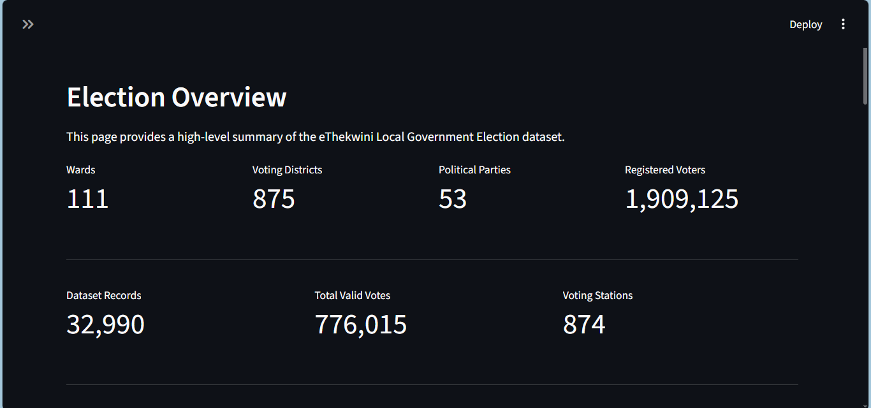Figure 1: Election Overview dashboard

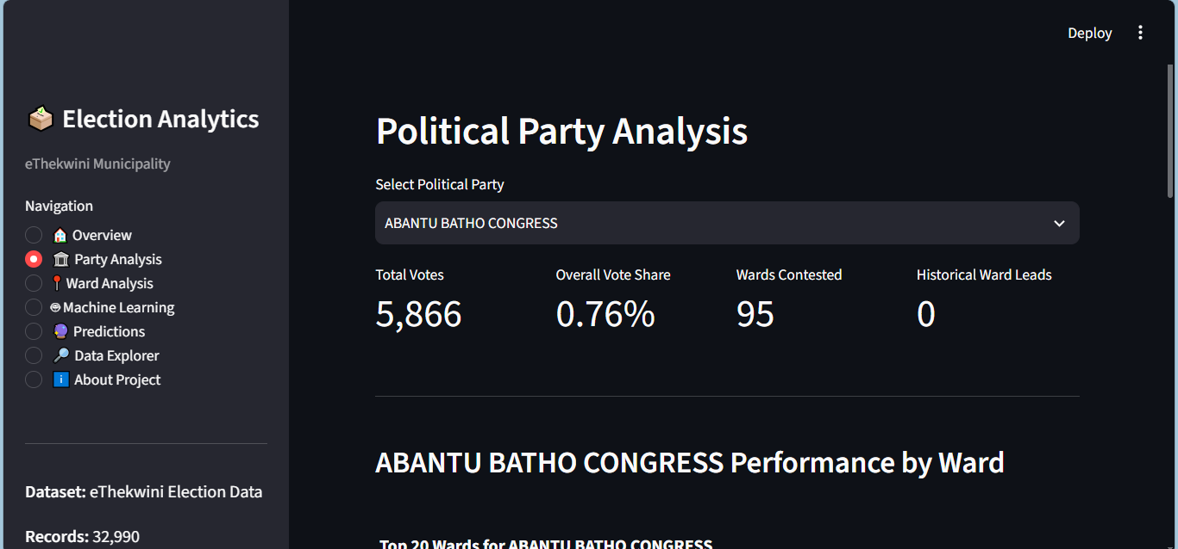Figure 2: Political Party Analysis

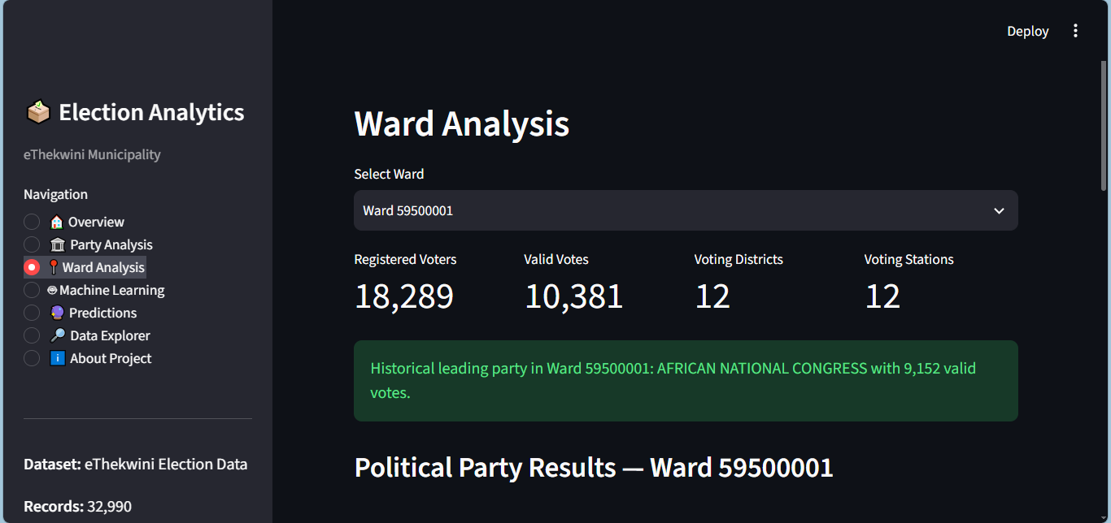Figure 3: Ward Analysis

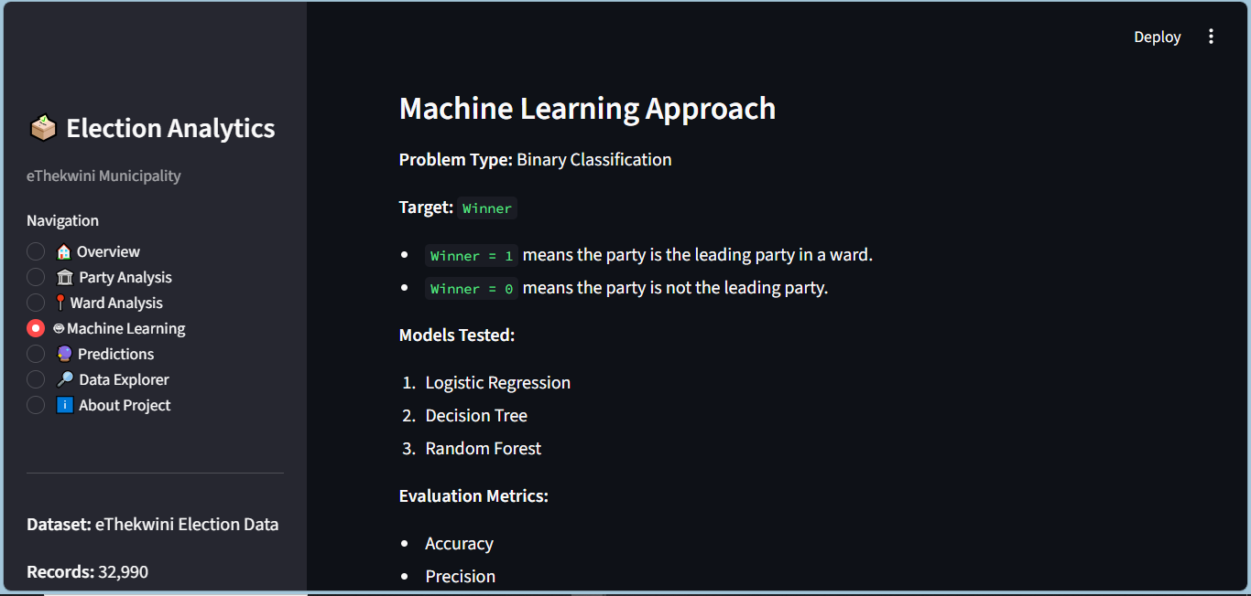Figure 4: Machine Learning Evaluation

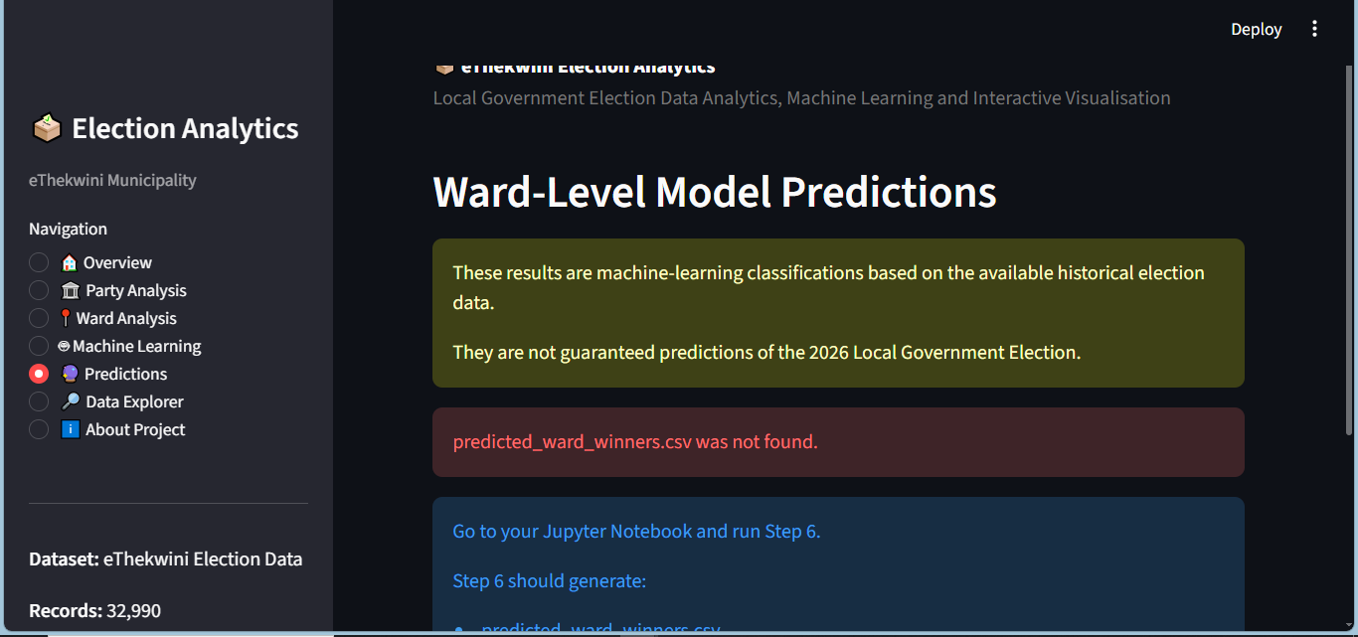Figure 5: Ward-Level Predictions

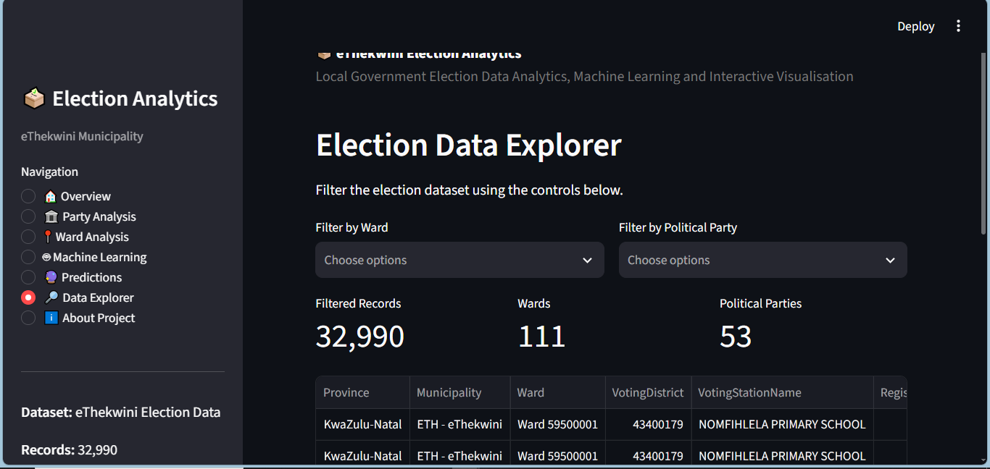Figure 6: Data Explorer

13. Testing and Validation
The completed solution should be tested from both the notebook and dashboard. Dataset dimensions, missing values, duplicate rows, registered-voter aggregation, party totals, ward winners and prediction probability ranges should be validated. Streamlit controls should be tested manually to ensure that selections update charts and tables correctly.
Test | Expected Result | Status
Dataset loads | Dataset loads without errors | Pass / Verify
Overview page | KPI cards and graphs display | Pass / Verify
Party selection | Metrics and chart update | Pass / Verify
Ward selection | Ward results update | Pass / Verify
ML page | Model metrics display | Pass / Verify
Prediction page | Ward prediction and probability display | Pass / Verify
Data Explorer | Filters update table | Pass / Verify
CSV download | Filtered CSV downloads | Pass / Verify

14. Results and Findings
- The dataset contains 32,990 records and 11 original columns.
- Election records are organised across wards, voting districts, voting stations and political parties.
- Registered-voter values repeat across party records, so unique voting-district records must be used when calculating voter totals.
- Party-level aggregation makes it possible to rank political parties by valid votes and calculate vote share.
- Ward-level aggregation makes it possible to identify historical leading parties within individual wards.
- The Winner target is highly imbalanced because each ward contains many non-winning party records but only one leading party record.
- Accuracy alone is therefore not sufficient for model selection; precision, recall and F1-score are necessary.
- Random Forest was tuned using Grid Search and stratified cross-validation.
- The Streamlit application successfully integrates analytical results into an interactive dashboard.
Add the exact strongest party, exact ward counts, exact final model scores and other numerical findings from the executed notebook before submission.

15. Limitations
- The available data represents a limited historical election period, which restricts genuine future forecasting.
- Encoded party and ward identifiers are categorical labels and do not directly measure political support.
- The initial row-level train/test split can allow records from the same ward to appear in both training and testing data; a grouped ward split would provide a stricter future experiment.
- The model does not include previous election vote share, party growth/decline, candidate effects, demographic information, economic conditions, campaign activity or political events.
- Ward boundaries and political conditions may change between election periods.
- Prediction probabilities represent model confidence under the available feature set and are not guaranteed real-world probabilities of future victory.

16. Recommendations and Future Improvements
- Collect and combine multiple historical Local Government Election datasets.
- Create features such as previous party vote share, vote-share change, previous ward winner and historical turnout.
- Use one-hot encoding or other appropriate categorical representations instead of treating label-encoded categories as ordered quantities.
- Use a grouped train/test split by ward to reduce information sharing between training and test sets.
- Compare additional models and perform more extensive hyperparameter optimisation.
- Add geographical ward maps and historical trend visualisations to the Streamlit dashboard.
- Evaluate calibration of prediction probabilities before interpreting them as future-election probabilities.
- Keep the dashboard wording clear about the difference between historical analysis, classification and future forecasting.

17. Conclusion
This project demonstrates a complete data-analytics workflow using eThekwini Local Government Election data. The dataset was loaded, cleaned and explored before being transformed into a machine-learning dataset. Political-party performance, ward patterns, registered voters and historical ward leaders were analysed through numerical summaries and visualisations.
Logistic Regression, Decision Tree and Random Forest classification models were trained and evaluated. Random Forest was then optimised using hyperparameter tuning and cross-validation. The modelling process highlighted the importance of using precision, recall and F1-score when the target classes are imbalanced.
An interactive Streamlit dashboard was developed to communicate the analytical results. The dashboard provides election overview statistics, party analysis, ward analysis, machine-learning results, model classifications and data exploration.
The project provides a useful foundation for election analytics, but its current model outputs should not be presented as definitive 2026 election forecasts. A stronger forecasting system would require several historical election periods and richer explanatory variables. With those improvements, the project could be extended into a more robust election trend and forecasting platform.

Appendix A: Final Submission Checklist
☐ Run the notebook from top to bottom without errors.
☐ Replace every [Insert] placeholder in this report with actual notebook output.
☐ Insert clean Streamlit screenshots with no visible error messages.
☐ Confirm predicted_ward_winners.csv and model_evaluation_summary.csv are generated.
☐ Confirm app.py and ETH_Ward.csv are in the correct project folder.
☐ Test all six Streamlit pages.
☐ Check spelling, headings, figure captions and page numbering.
☐ Submit the notebook, dataset, app.py, report and any required model/output files.

